# GSI023 – REDE DE COMPUTADORES

**Computer Networking – J. F. Kurose and K. W. Ross – 7th Edition Chapter 2 – Camadas de Aplicação**

**Pedro Henrique Silva Santana – 12011BSI218 –** [**pedro.santana@ufu.br**](mailto:pedro.santana@ufu.br)

**Victor Hugo Martins Alves – 12011BSI217 – victor.alves1@ufu.br**

1.Run nslookup to obtain the IP address of a Web server in Asia. What is its IP address?

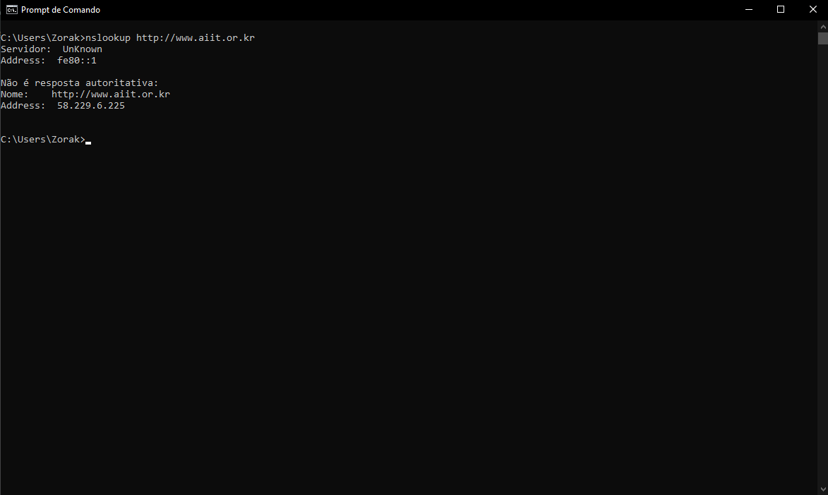

O endereço é 58.229.6.225

2. Run nslookup to determine the authoritative DNS servers for a university in Europe. What is its IP address.

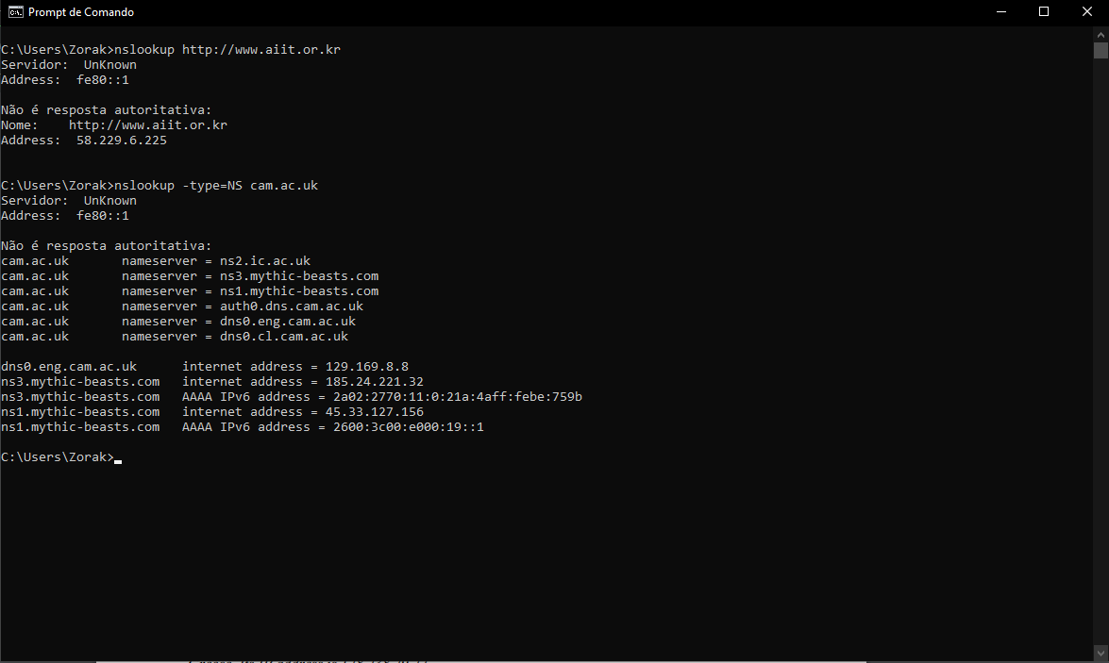

O endereço IP da Universidade de Cambridge é : 129.169.8.8

3. Run nslookup so that one of the DNS servers obtained in Question 2 is queried for the mail servers for Yahoo! mail. What is its IP address?

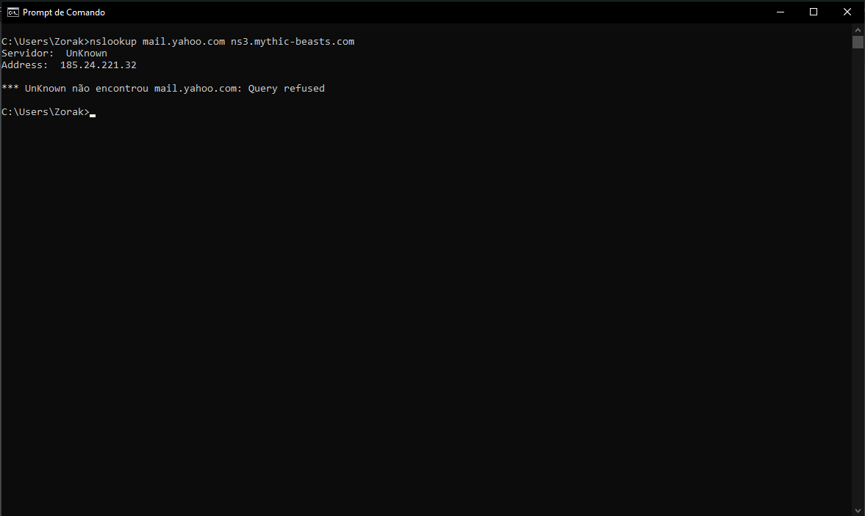

O endereço IP é: 185.24.221.32

4. Locate the DNS query and response messages. Are then sent over UDP or TCP?

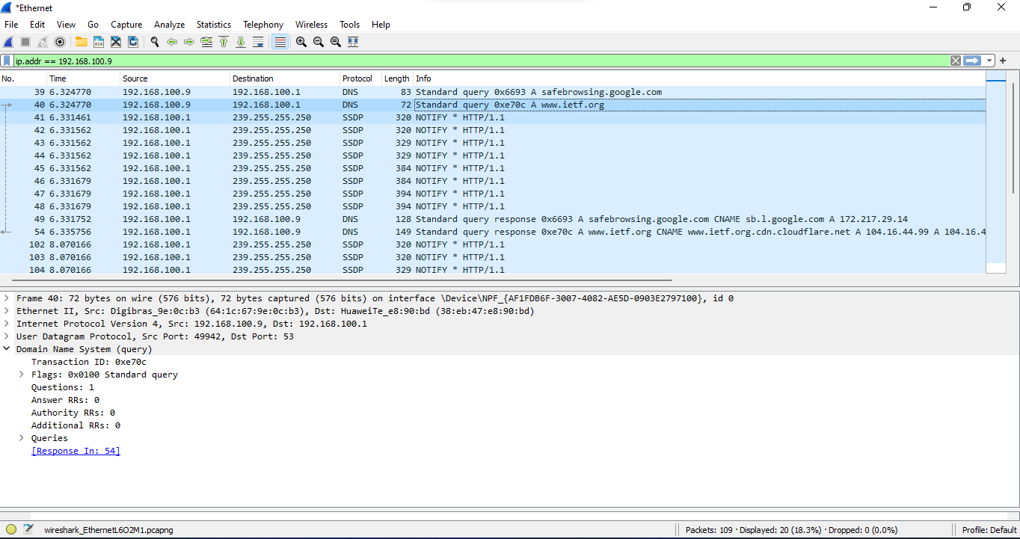

Requisição.

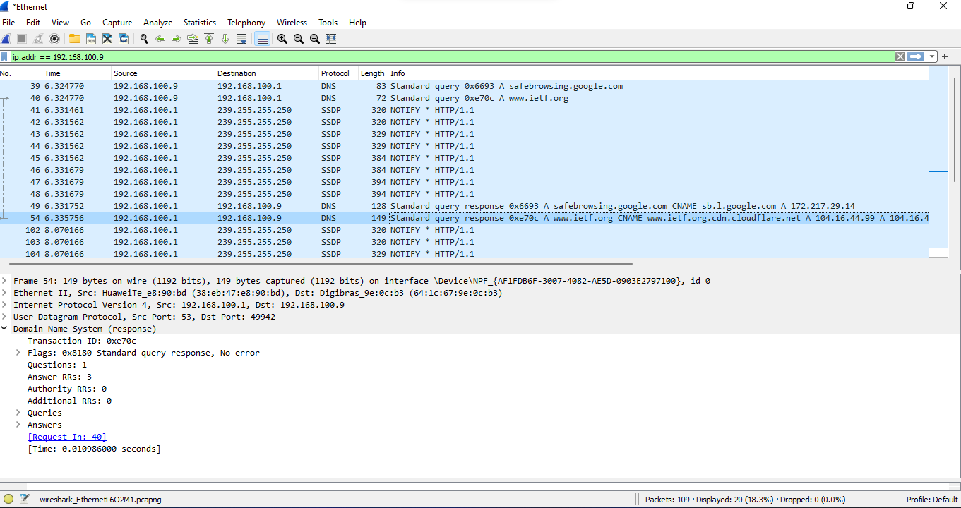

Resposta.

Foram enviados via UDP.

5. What is the destination port for the DNS query message? What is the source port of DNS response message?

Porta 53 para ambas.

6. To what IP address is the DNS query message sent? Use ipconfig to determine the IP address of your local DNS server. Are these two IP addresses the same?



192.168.100.1. Sim, este é um dos endereços DNS local.

7. Examine the DNS query message. What “Type” of DNS query is it? Does the query message contain any “answers”?

Standard Query. Não possui nenhuma resposta.

8. Examine the DNS response message. How many “answers” are provided? What do each of these answers contain?

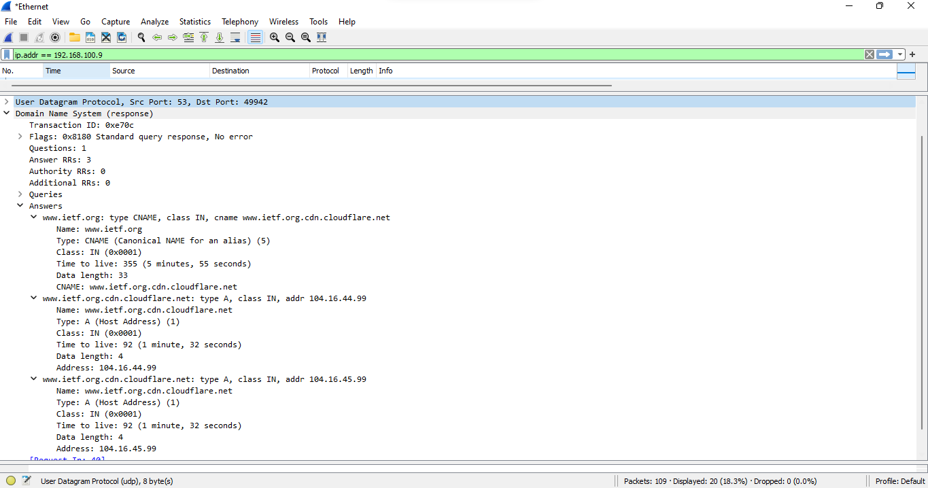

Foram providas 3 respostas. Elas contem: nome, tipo, classe, tempo de vida, tamanho de dados e endereço OU cname.

9. Consider the subsequent TCP SYN packet sent by your host. Does the destination IP address of the SYN packet correspond to any of the IP addresses provided in the DNS response message?

Sim.

10. This web page contains images. Before retrieving each image, does your host issue new DNS queries?

Não.

11. What is the destination port for the DNS query message? What is the source port of DNS response message?

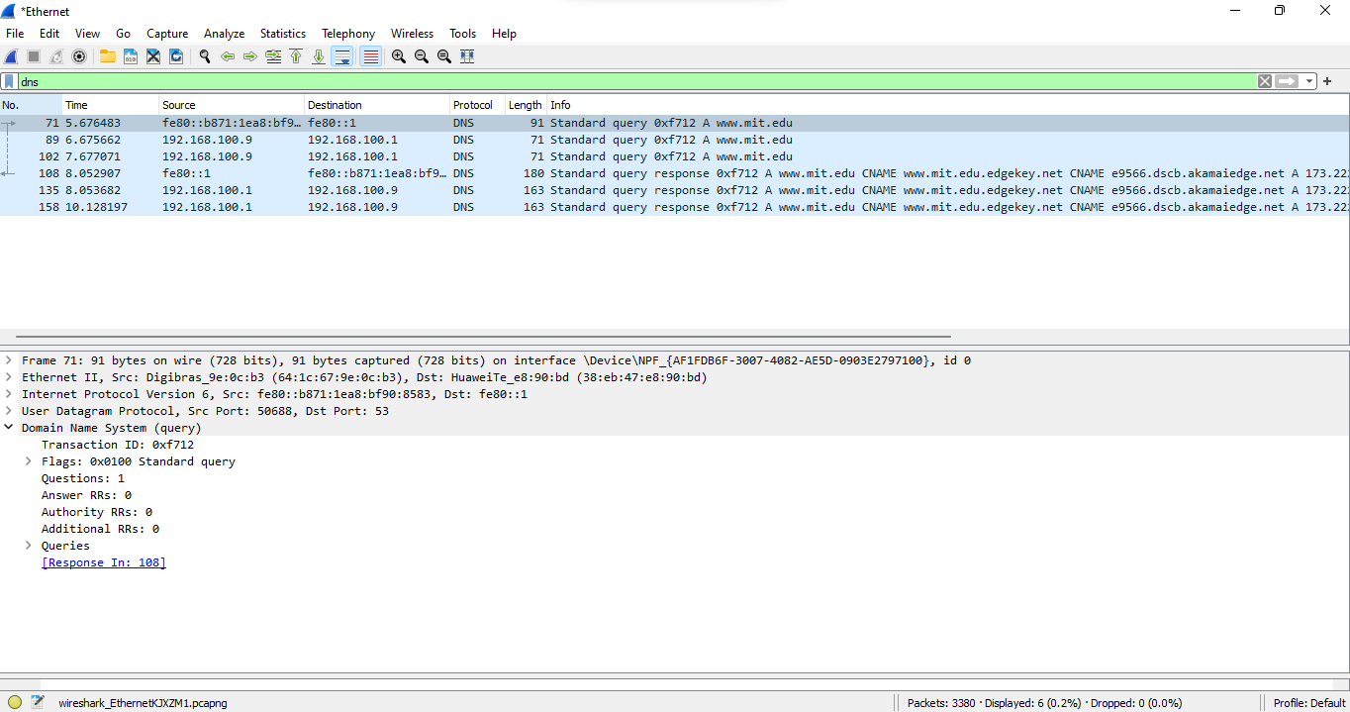

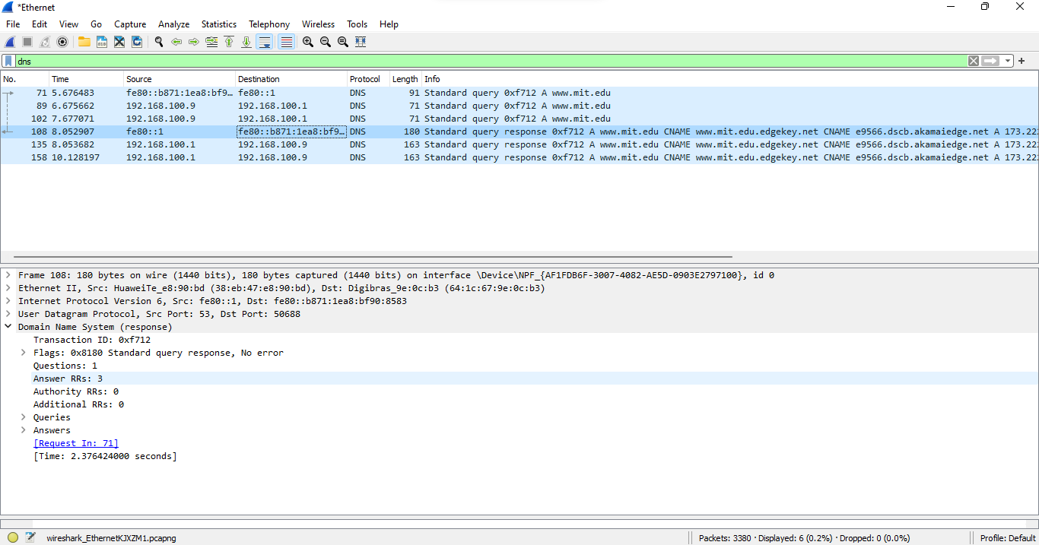

Destination Port da query 53, Source Port da response 53.

12. To what IP address is the DNS query message sent? Is this the IP address of your default local DNS server?



192.168.100.1, sim é o endereço do servidor DNS local.

13. Examine the DNS query message. What “Type” of DNS query is it? Does the query message contain any “answers”?

Standard query. Não contém nenhuma resposta.

14. Examine the DNS response message. How many “answers” are provided? What do each of these answers contain?

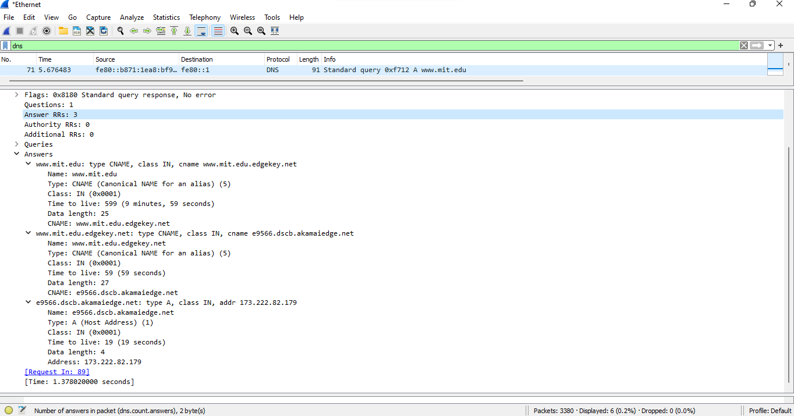

3 respostas que possuem o nome do host, tipo, classe, tempo de vida, tamanho e o endereço IP.

15. Provide a screenshot.

16. To what IP address is the DNS query message sent? Is this the IP address of your default local DNS server?

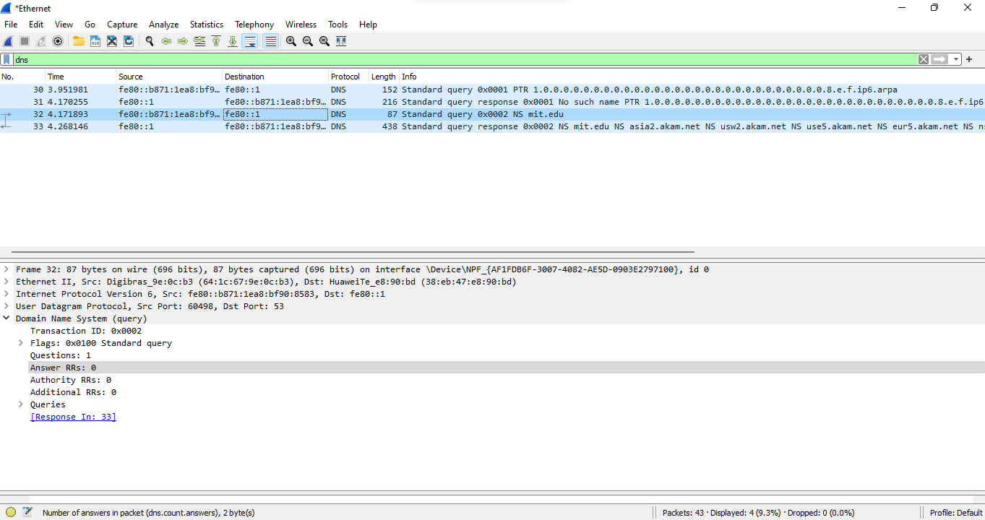

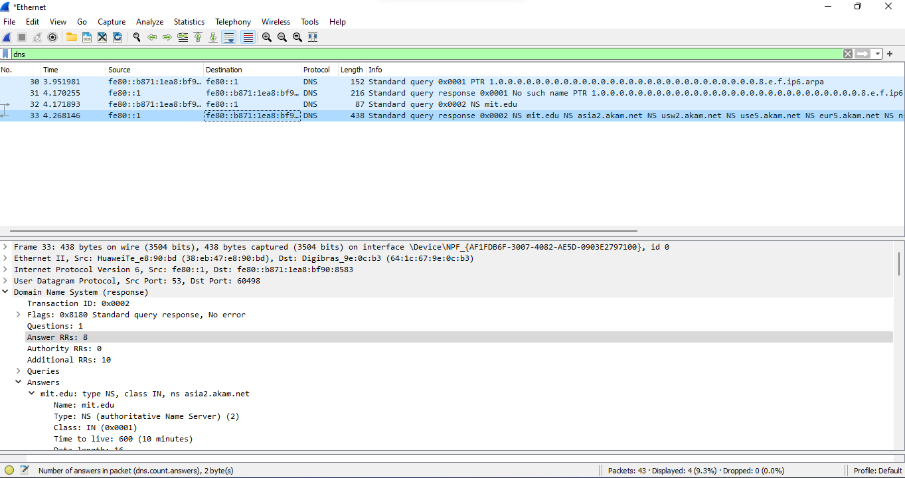

Fe80::1, sim é o endereço do servidor DNS local.

17. Examine the DNS query message. What “Type” of DNS query is it? Does the query message contain any “answers”?

Standard query, não possui respostas.

18. Examine the DNS response message. What MIT nameservers does the response message provide? Does this response message also provide the IP addresses of the MIT namesers?

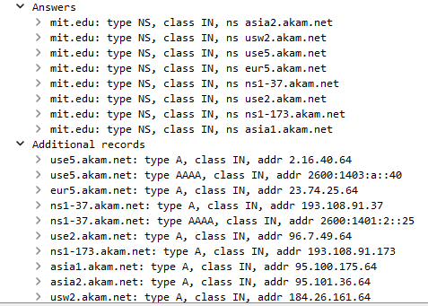

Os nomes dos servidores estão listados abaixo, assim como o IP no Additional records.

19. Provide a screenshot.

20. To what IP address is the DNS query message sent? Is this the IP address of your default local DNS server? If not, what does the IP address correspond to?

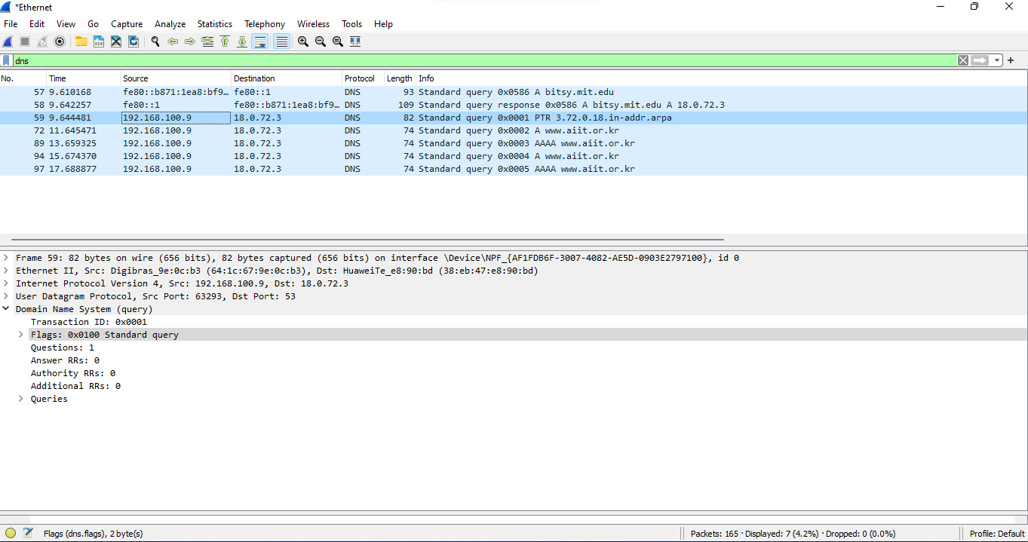

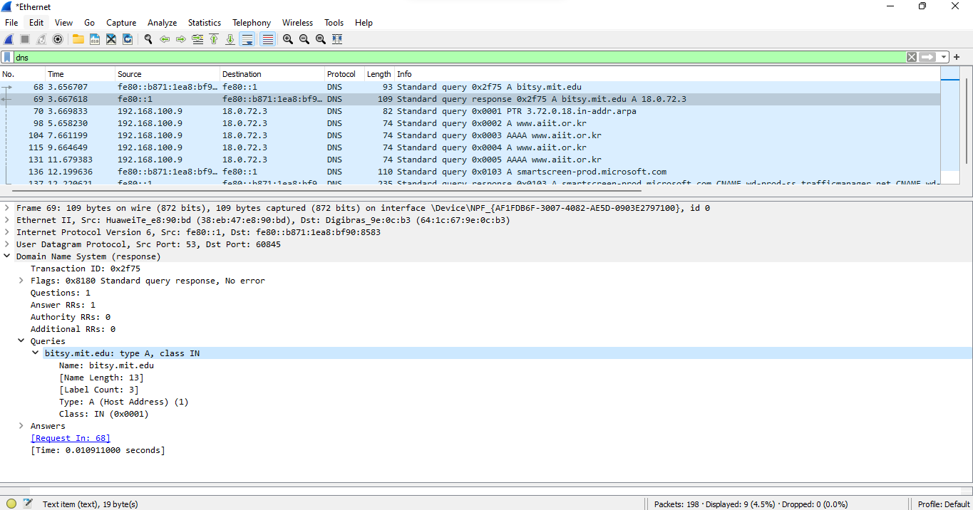

18.0.72.3, que corresponde ao bitsy.mit.edu

21. Examine the DNS query message. What “Type” of DNS query is it? Does the query message contain any “answers”?

Standand query, não contém nenhuma resposta.

22. Examine the DNS response message. How many “answers” are provided? What does each of these answers contain?

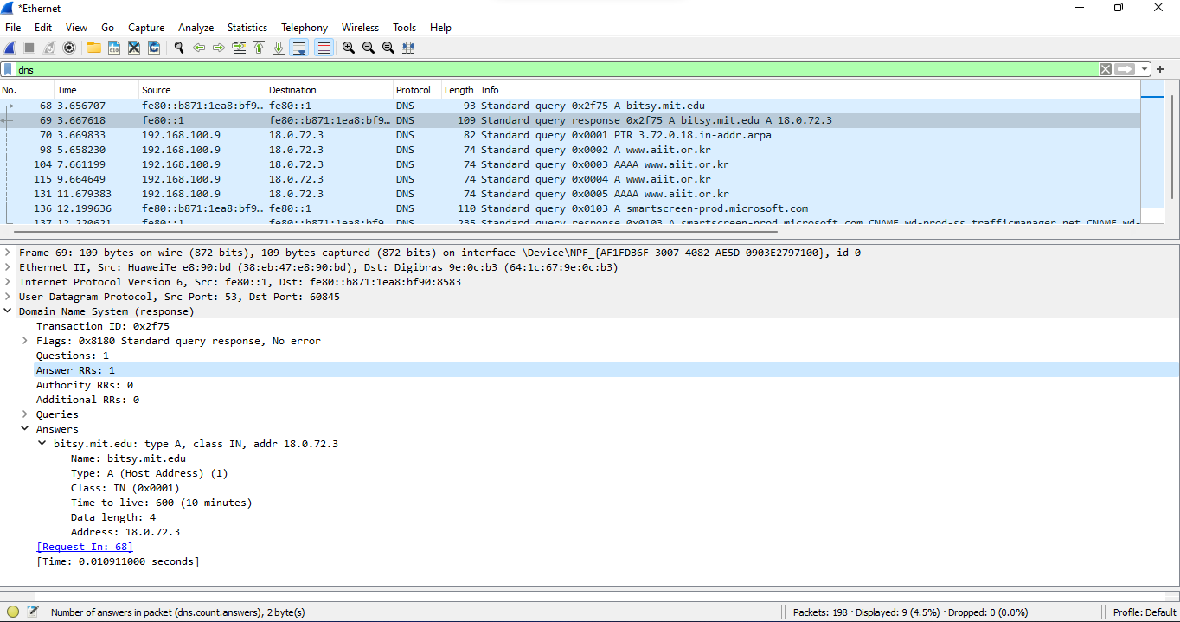

Possui uma resposta, com o nome do host, tipo, classe, tempo de vida, tamanho e o endereço IP.

23. Provide a screenshot.